VAXORA
Vaccination Management System

DEVELOPER’S GUIDE

Version 1.0
May 2026

Technical Documentation for Developers

Table of Contents
Table of Contents 2
1. System Overview 4
1.1 Project Description 4
1.2 Technology Stack 4
1.3 Architecture Pattern 4
2. Directory Structure 5
2.1 Project Layout 5
3. Database Design 7
3.1 Database Schema Overview 7
3.2 Table: users 7
3.3 Table: hospitals 7
3.4 Table: children 8
3.5 Table: vaccines 8
3.6 Table: appointments 9
3.7 Table: vaccination_records 9
3.8 Table: reviews 10
4. Module Descriptions 11
4.1 Configuration Module (config.php) 11
4.2 Authentication Module (auth.php) 11
4.3 Registration Module (register.php) 12
4.4 Parent Dashboard Module (parent/index.php) 12
4.5 Children Management Module (parent/children.php) 12
4.6 Appointment Booking Module (parent/book-hospital.php) 13
4.7 Admin Requests Module (admin/requests.php) 13
4.8 Vaccine Management Module (admin/vaccines.php) 14
4.9 Hospital Management Module (admin/hospitals.php) 14
4.10 Hospital Vaccine Status Module (hospital/vaccine-status.php) 14
4.11 Email Notification Module (includes/mailer.php) 14
4.12 Review Management Module (admin/reviews.php) 15
4.13 Public Pages Module 15
4.14 Dashboard Layout Module (includes/dash-header.php & dash-footer.php) 15
5. Security Implementation 16
5.1 Authentication Security 16
5.2 Input Validation & Sanitization 16
5.3 SQL Injection Prevention 16
5.4 XSS Prevention 16
5.5 Access Control 16
6. Installation & Setup 17
6.1 Prerequisites 17
6.2 Installation Steps 17
6.3 Default Login Credentials 17
6.4 Email Configuration 17
7. Data Flow & Process Diagrams 19
7.1 Appointment Booking Flow 19
7.2 User Authentication Flow 19
7.3 Data Flow Diagram (DFD) - Level 0 19
7.4 Data Flow Diagram (DFD) - Level 1 20
8. Key Code Patterns 21
8.1 Database Query Pattern 21
8.2 Authentication Guard Pattern 21
8.3 Flash Message Pattern 21
8.4 CRUD Page Pattern 21
9. Testing & Maintenance 23
9.1 Testing the Application 23
9.2 Common Maintenance Tasks 23
9.3 Extending the System 23

1. System Overview

1.1 Project Description
VAXORA is a full-stack web application built with PHP and MySQL for managing vaccination appointments across Pakistan. The system follows a traditional server-rendered MVC-like architecture using PHP with PDO for database operations, session-based authentication, and a responsive frontend using custom CSS and vanilla JavaScript.

1.2 Technology Stack
Component | Technology | Version
Backend Language | PHP | 7.4+
Database | MySQL / MariaDB | 5.7+
Database Abstraction | PDO (PHP Data Objects) | Built-in
Server | Apache / Nginx | 2.4+ / 1.18+
Frontend | HTML5, CSS3, Vanilla JavaScript | ES6
CSS Framework | Custom CSS (style.css) | N/A
Email Library | PHPMailer | 6.x
Dependency Manager | Composer | 2.x
Local Development | XAMPP / WAMP / LAMP | Latest

1.3 Architecture Pattern
The application uses a page-based architecture where each PHP file acts as both controller and view. Key architectural decisions:
- No MVC framework – lightweight, self-contained PHP files
- Shared includes for common functionality (header, footer, config, auth)
- PDO with prepared statements for all database queries (SQL injection prevention)
- Session-based authentication with role-based access control
- Flash messages for user notifications across redirects
- Auto-detecting SITE_URL for portability across different environments

2. Directory Structure

2.1 Project Layout
vaxora-php/
├── admin/ # Admin panel pages
│ ├── index.php # Admin dashboard
│ ├── login.php # Admin login page
│ ├── bookings.php # All booking details
│ ├── children.php # View all children
│ ├── hospitals.php # CRUD for hospitals
│ ├── reports.php # System reports
│ ├── requests.php # Approve/reject appointments
│ ├── reviews.php # Moderate reviews
│ ├── vaccination-dates.php # All vaccination dates
│ └── vaccines.php # CRUD for vaccines
├── parent/ # Parent dashboard pages
│ ├── index.php # Parent dashboard
│ ├── children.php # Manage children (CRUD)
│ ├── book-hospital.php # Book vaccination appointment
│ ├── requests.php # View appointment status
│ ├── vaccination-dates.php # Scheduled dates
│ ├── reports.php # Vaccination records
│ └── profile.php # Edit profile
├── hospital/ # Hospital staff pages
│ ├── index.php # Hospital dashboard
│ └── vaccine-status.php # Update vaccination status
├── includes/ # Shared PHP includes
│ ├── header.php # Public page header/nav
│ ├── footer.php # Public page footer
│ ├── dash-header.php # Dashboard sidebar/header
│ ├── dash-footer.php # Dashboard footer
│ └── mailer.php # PHPMailer configuration
├── assets/
│ ├── css/style.css # All custom styles
│ └── js/main.js # Frontend JavaScript
├── vendor/ # Composer dependencies
├── config.php # DB connection & helpers
├── auth.php # Authentication functions
├── index.php # Homepage
├── login.php # User login
├── register.php # User registration
├── logout.php # Session destroy
├── vaccines.php # Public vaccines page
├── hospitals.php # Public hospitals page
├── about.php # About page
├── contact.php # Contact form + reviews
├── blog.php # Blog articles
├── vaxora.sql # Database schema + sample data
└── composer.json # PHP dependencies

3. Database Design

3.1 Database Schema Overview
The system uses a MySQL database named 'vaxora_db' with the following tables:

Table Name | Purpose | Key Relationships
users | Stores all user accounts (admin, parent, hospital) | Primary user table
hospitals | Hospital/clinic information | FK: user_id -> users.id
children | Children registered by parents | FK: parent_id -> users.id
vaccines | Vaccine catalog with details | Referenced by appointments
appointments | Vaccination appointment bookings | FK: parent_id, child_id, hospital_id, vaccine_id
vaccination_records | Completed vaccination records | FK: appointment_id, child_id, vaccine_id, hospital_id
contacts | Contact form submissions | Standalone
reviews | Patient reviews for homepage | FK: parent_id -> users.id (optional)

3.2 Table: users
Stores all system users with role-based differentiation.
Column | Type | Constraints | Description
id | INT(11) | PK, AUTO_INCREMENT | Unique user identifier
name | VARCHAR(100) | NOT NULL | Full name
email | VARCHAR(150) | NOT NULL, UNIQUE | Login email
password | VARCHAR(255) | NOT NULL | bcrypt hashed password
role | ENUM | admin/parent/hospital | User role for access control
phone | VARCHAR(20) | NULL | Contact phone
city | VARCHAR(100) | NULL | User city
address | TEXT | NULL | Full address
status | ENUM | active/inactive | Account status
created_at | TIMESTAMP | DEFAULT CURRENT_TIMESTAMP | Registration date

3.3 Table: hospitals
Stores hospital/clinic details linked to user accounts.
Column | Type | Constraints | Description
id | INT(11) | PK, AUTO_INCREMENT | Hospital identifier
user_id | INT(11) | FK -> users.id, NULL | Linked hospital user account
name | VARCHAR(200) | NOT NULL | Hospital name
address | TEXT | NULL | Physical address
city | VARCHAR(100) | NULL | City location
phone | VARCHAR(20) | NULL | Contact number
email | VARCHAR(150) | NULL | Hospital email
rating | DECIMAL(2,1) | DEFAULT 4.5 | Rating (0-5)
services | TEXT | NULL | Comma-separated services
hours | VARCHAR(100) | NULL | Operating hours
status | ENUM | active/inactive | Visibility status

3.4 Table: children
Stores children registered by parent users.
Column | Type | Constraints | Description
id | INT(11) | PK, AUTO_INCREMENT | Child identifier
parent_id | INT(11) | FK -> users.id, CASCADE | Parent who owns record
name | VARCHAR(100) | NOT NULL | Child full name
dob | DATE | NOT NULL | Date of birth
gender | ENUM | male/female/other | Gender
blood_group | VARCHAR(10) | NULL | Blood group
weight | DECIMAL(5,2) | NULL | Weight in kg
height | DECIMAL(5,2) | NULL | Height in cm
notes | TEXT | NULL | Additional notes

3.5 Table: vaccines
Catalog of all vaccines available in the system.
Column | Type | Constraints | Description
id | INT(11) | PK, AUTO_INCREMENT | Vaccine identifier
name | VARCHAR(200) | NOT NULL | Vaccine name
type | VARCHAR(100) | NULL | Vaccine type (mRNA, etc.)
doses | INT(11) | DEFAULT 1 | Number of doses required
age_group | VARCHAR(100) | NULL | Recommended age group
description | TEXT | NULL | Full description
side_effects | TEXT | NULL | Known side effects
duration | VARCHAR(100) | NULL | Protection duration
status | ENUM | available/unavailable | Availability status

3.6 Table: appointments
Core table for vaccination appointment bookings with workflow status tracking.
Column | Type | Constraints | Description
id | INT(11) | PK, AUTO_INCREMENT | Appointment identifier
parent_id | INT(11) | FK -> users.id | Booking parent
child_id | INT(11) | FK -> children.id | Child for vaccination
hospital_id | INT(11) | FK -> hospitals.id | Selected hospital
vaccine_id | INT(11) | FK -> vaccines.id | Selected vaccine
appointment_date | DATE | NOT NULL | Scheduled date
appointment_time | TIME | NULL | Preferred time
notes | TEXT | NULL | Parent notes
status | ENUM | pending/approved/rejected/completed/cancelled | Workflow status

3.7 Table: vaccination_records
Tracks actual vaccination events after hospital completes the procedure.
Column | Type | Constraints | Description
id | INT(11) | PK, AUTO_INCREMENT | Record identifier
appointment_id | INT(11) | FK -> appointments.id | Linked appointment
child_id | INT(11) | FK -> children.id | Vaccinated child
vaccine_id | INT(11) | FK -> vaccines.id | Administered vaccine
hospital_id | INT(11) | FK -> hospitals.id | Administering hospital
date_given | DATE | NULL | Actual vaccination date
next_due_date | DATE | NULL | Next dose due date
dose_number | INT(11) | DEFAULT 1 | Dose sequence number
status | ENUM | completed/missed/pending | Vaccination outcome
notes | TEXT | NULL | Hospital observations

3.8 Table: reviews
Patient reviews displayed on the homepage after admin approval.
Column | Type | Constraints | Description
id | INT(11) | PK, AUTO_INCREMENT | Review identifier
parent_id | INT(11) | FK -> users.id, NULL | Reviewer (optional)
name | VARCHAR(100) | NOT NULL | Reviewer name
email | VARCHAR(150) | NOT NULL | Reviewer email
location | VARCHAR(100) | NULL | Reviewer city
rating | TINYINT(1) | DEFAULT 5 | Star rating (1-5)
review_text | TEXT | NOT NULL | Review content
status | ENUM | pending/approved/rejected | Moderation status

4. Module Descriptions

4.1 Configuration Module (config.php)
This is the core configuration file included by every page. It provides:
- Database connection constants (DB_HOST, DB_USER, DB_PASS, DB_NAME)
- Auto-detecting SITE_URL based on server environment variables
- PDO database connection via getDB() singleton function
- Session initialization
- Helper functions: redirect(), e() (HTML escape), setFlash(), getFlash(), showFlash()

Key Functions:
Function | Parameters | Return | Description
getDB() | None | PDO instance | Returns singleton PDO connection with error mode exception
redirect($url) | string $url | void (exits) | Sends Location header and terminates
e($str) | string $str | string | HTML entity escaping (XSS prevention)
setFlash($type, $msg) | string, string | void | Stores flash message in session
getFlash() | None | array|null | Retrieves and clears flash message
showFlash() | None | string | Returns HTML for flash message display

4.2 Authentication Module (auth.php)
Handles all authentication and authorization logic. Uses PHP sessions and bcrypt password hashing.

Key Functions:
Function | Parameters | Description
isLoggedIn() | None | Returns true if user_id exists in session
currentUser() | None | Returns current user array from session
requireLogin($role) | string|null $role | Redirects to login if not authenticated; checks role if provided
requireAdmin() | None | Restricts access to admin role only
requireParent() | None | Restricts access to parent role only
requireHospital() | None | Restricts access to hospital role only
loginUser($email, $password, $role) | string, string, string|null | Validates credentials, creates session, returns user or false
logoutUser() | None | Destroys session data
dashboardUrl($role) | string $role | Returns the dashboard URL for a given role

Authentication Flow:
- User submits email + password + role on login.php
- loginUser() queries users table with email and role filter
- password_verify() checks bcrypt hash
- On success: user_id and user array stored in $_SESSION
- Role-based redirects send users to appropriate dashboards
- requireAdmin/Parent/Hospital() guards protect dashboard pages

4.3 Registration Module (register.php)
Handles new user registration with form validation.
- Validates required fields, password match, minimum length (6 chars)
- Checks for duplicate email addresses
- Hashes password with password_hash(PASSWORD_DEFAULT)
- Inserts user record into users table
- For hospital role: also creates a hospital record with status 'inactive' (requires admin activation)
- Redirects to login with success flash message
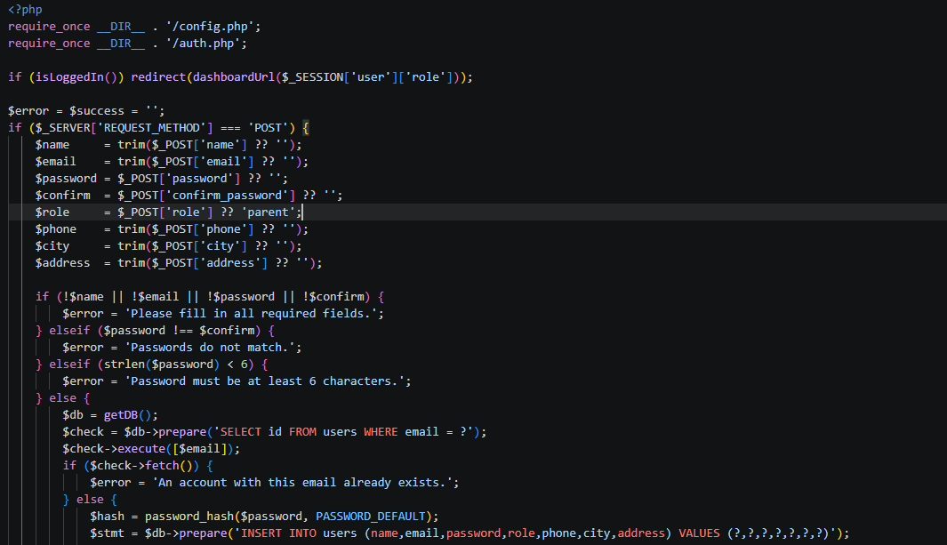

4.4 Parent Dashboard Module (parent/index.php)
Main dashboard for parent users, displaying aggregated statistics.
- Queries children count for logged-in parent
- Fetches upcoming appointments (approved or pending, future dates)
- Counts pending requests and completed vaccination records
- Renders widget cards, upcoming appointments table, children list, and quick actions
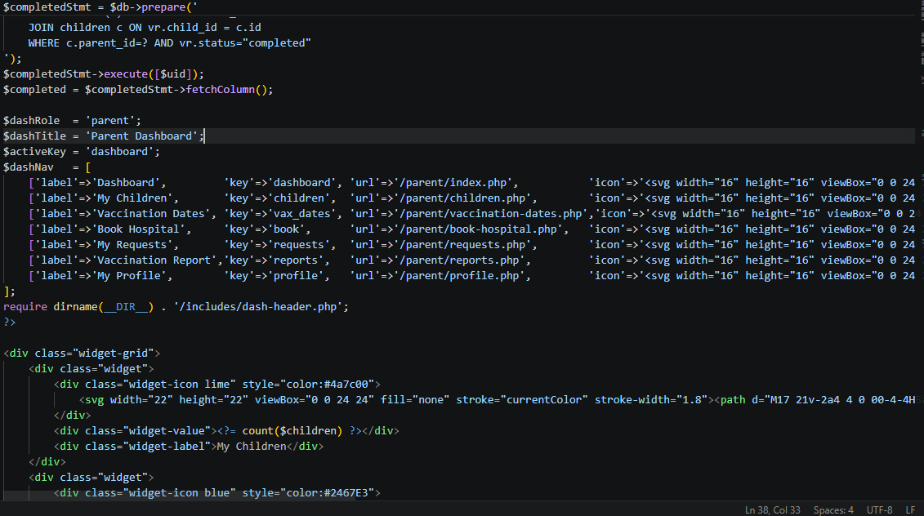

4.5 Children Management Module (parent/children.php)
Full CRUD operations for managing children records.
Operations:
- POST action='add': Inserts new child record linked to parent_id
- POST action='update': Updates existing child record (validates ownership)
- GET delete=id: Deletes child record (validates parent_id ownership)
- GET edit=id: Loads child data into edit form

Security:
- All queries include parent_id check to prevent unauthorized access
- Input values are trimmed; numeric fields cast appropriately
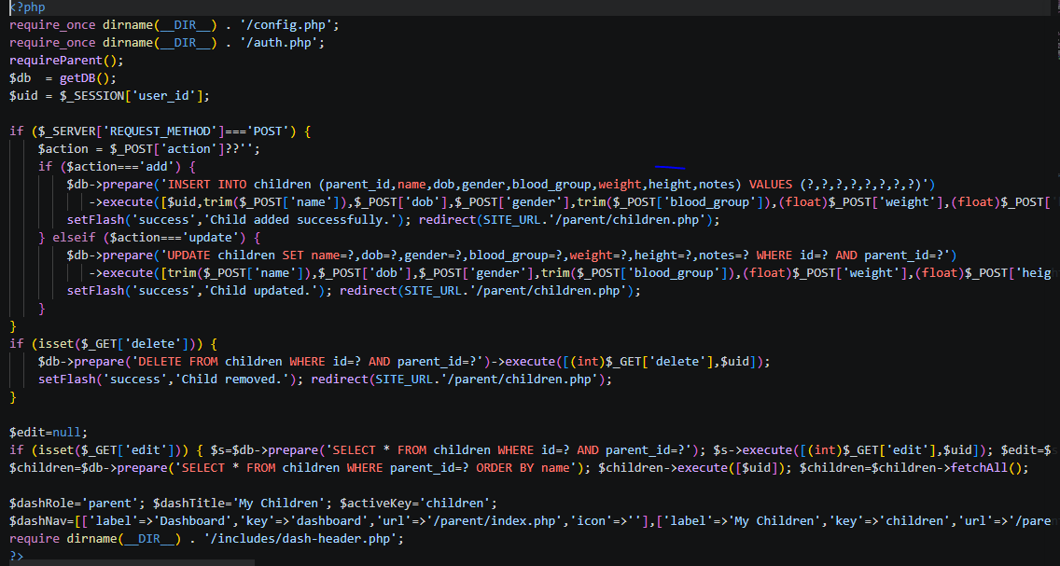

4.6 Appointment Booking Module (parent/book-hospital.php)
Allows parents to submit vaccination appointment requests.
Process Flow:
- Loads parent's children, active hospitals, and available vaccines
- Validates child belongs to current parent (ownership check)
- Validates appointment date is not in the past
- Inserts appointment with status 'pending'
- Redirects to requests page with success message

Hospital Directory:
- Right panel displays all active hospitals with city filter tabs
- Shows hospital name, rating, city, address, hours, and services
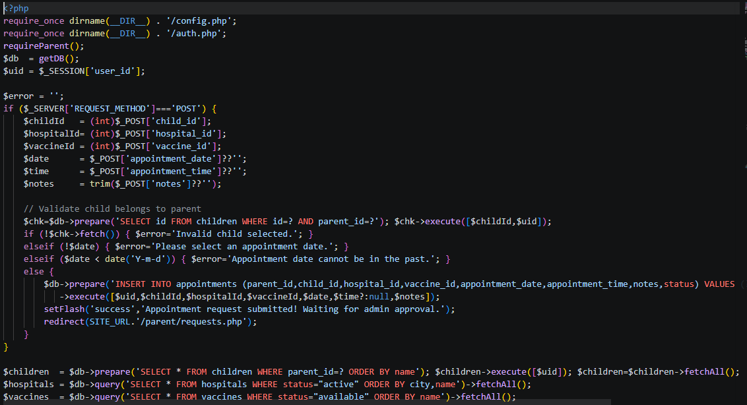

4.7 Admin Requests Module (admin/requests.php)
Admin interface for managing vaccination appointment requests.
Workflow Actions:
- Approve: Updates appointment status to 'approved' and creates vaccination_records placeholder
- Reject: Updates appointment status to 'rejected'
- Mark Done: Updates appointment status to 'completed'
- Email: Sends notification to parent via PHPMailer on approve/reject

Filtering:
- Filter tabs: All, Pending, Approved, Rejected, Completed
- SQL query adjusts WHERE clause based on selected filter

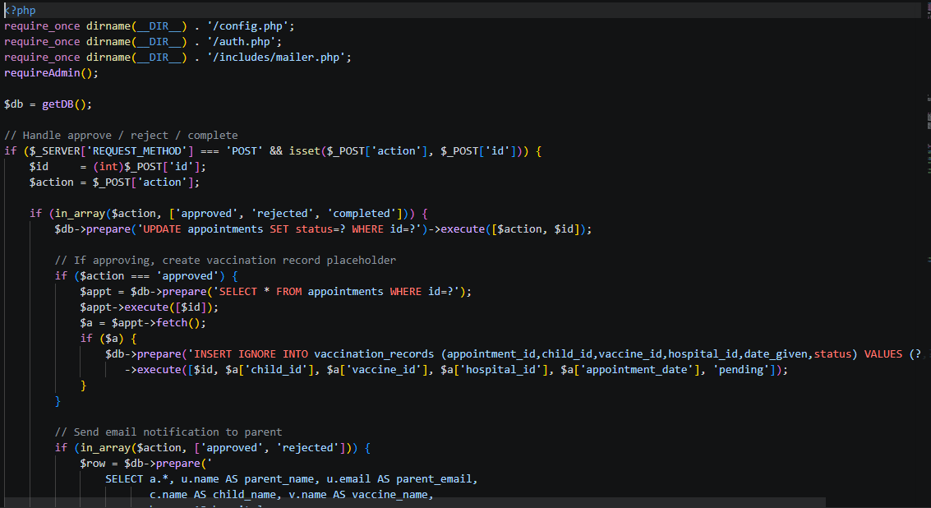

4.8 Vaccine Management Module (admin/vaccines.php)
Admin CRUD for managing the vaccine catalog.
- Add: Inserts new vaccine with all details (name, type, doses, age group, description, side effects, duration, status)
- Update: Modifies existing vaccine record by ID
- Delete: Permanently removes vaccine (GET ?delete=id)
- Toggle: Switches status between 'available' and 'unavailable' (GET ?toggle=id)
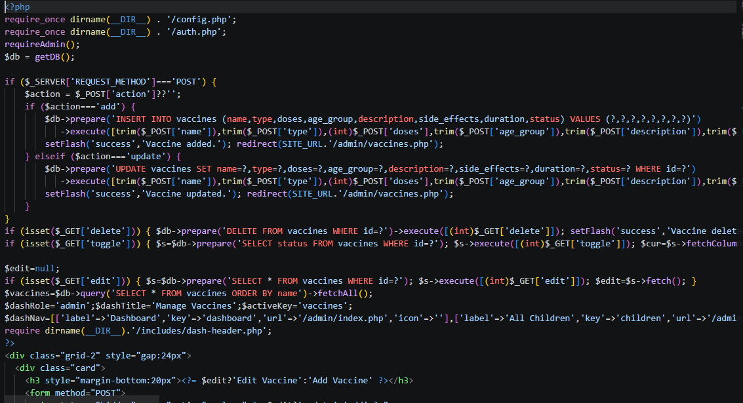

4.9 Hospital Management Module (admin/hospitals.php)
Admin CRUD for managing partner hospitals.
- Add: Inserts new hospital with default status 'active'
- Update: Modifies hospital details including status
- Delete: Permanently removes hospital record
- Toggle: Switches status between 'active' and 'inactive'
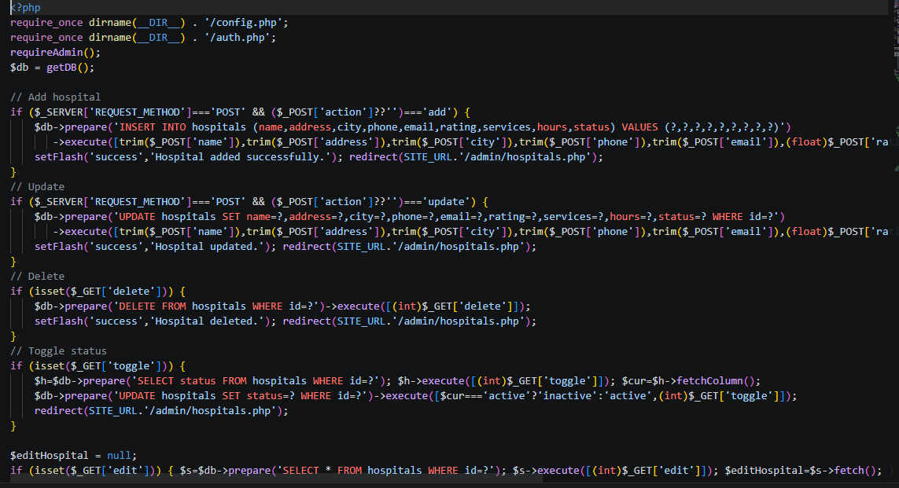

4.10 Hospital Vaccine Status Module (hospital/vaccine-status.php)
Hospital interface for updating vaccination outcomes.
Process:
- Verifies hospital user owns the hospital record
- Displays appointments assigned to this hospital with filter tabs
- On status update: updates appointment status to 'completed'
- Upserts vaccination_records: creates or updates the record
- Records: status (completed/missed), date_given, next_due_date, dose_number, notes
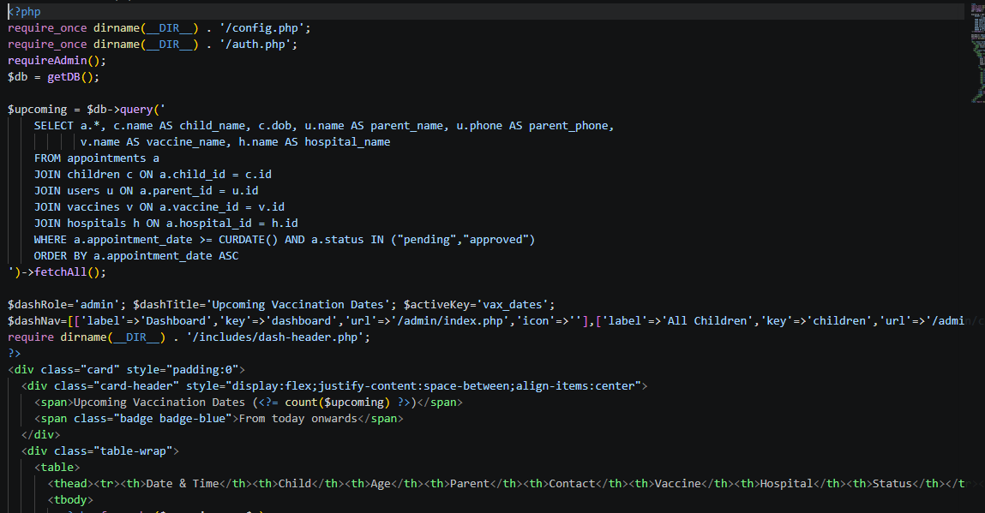

4.11 Email Notification Module (includes/mailer.php)
Configures PHPMailer for sending email notifications to parents.
- MAIL_ENABLED constant controls whether emails are sent
- SMTP configuration: host, port, username, password, encryption
- sendAppointmentStatusEmail() function formats and sends status emails
- Email includes: child name, vaccine, hospital, date, and new status
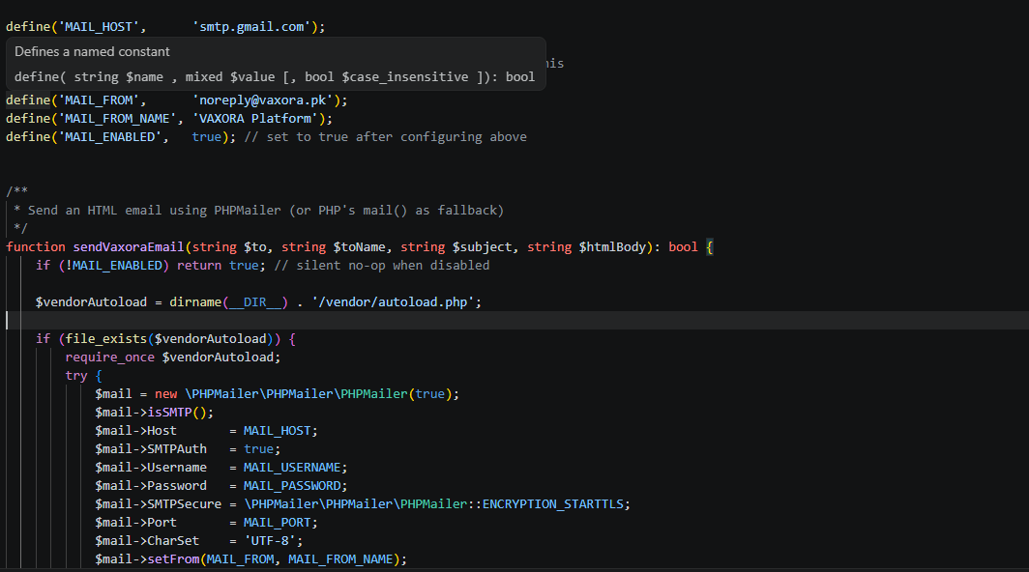

4.12 Review Management Module (admin/reviews.php)
Admin interface for moderating patient reviews.
- Displays all reviews with rating, text, author, location, and submission date
- Actions: Approve (makes visible on homepage), Reject (hides review)
- Homepage displays only reviews with status 'approved'
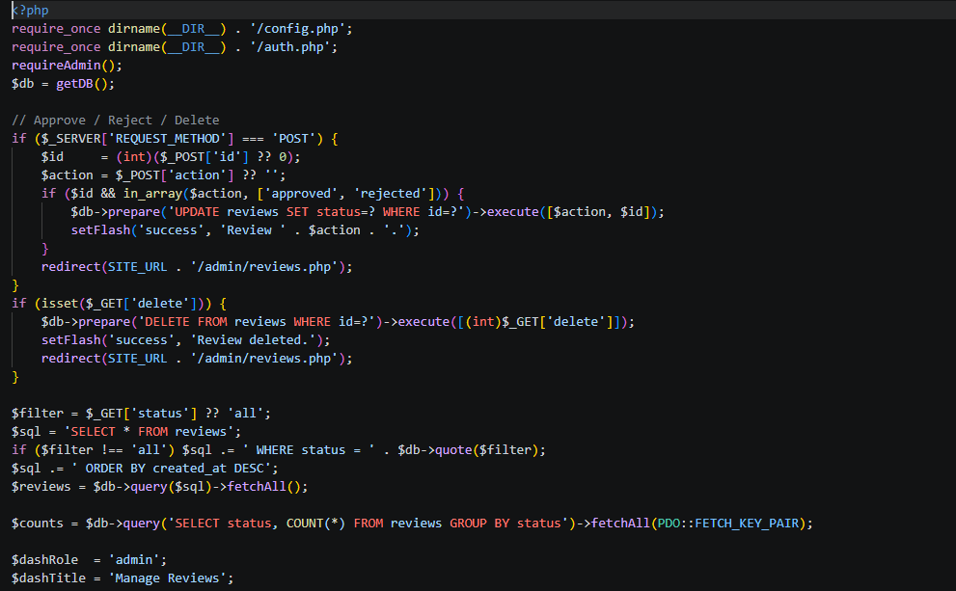

4.13 Public Pages Module
Public-facing pages accessible without authentication:
- index.php: Homepage with dynamic content (hospitals from DB, reviews from DB)
- vaccines.php: Full vaccine catalog from database
- hospitals.php: Active hospitals directory with city filtering
- about.php: Static about page
- contact.php: Contact form (inserts to contacts table) + review submission
- blog.php: Static blog articles
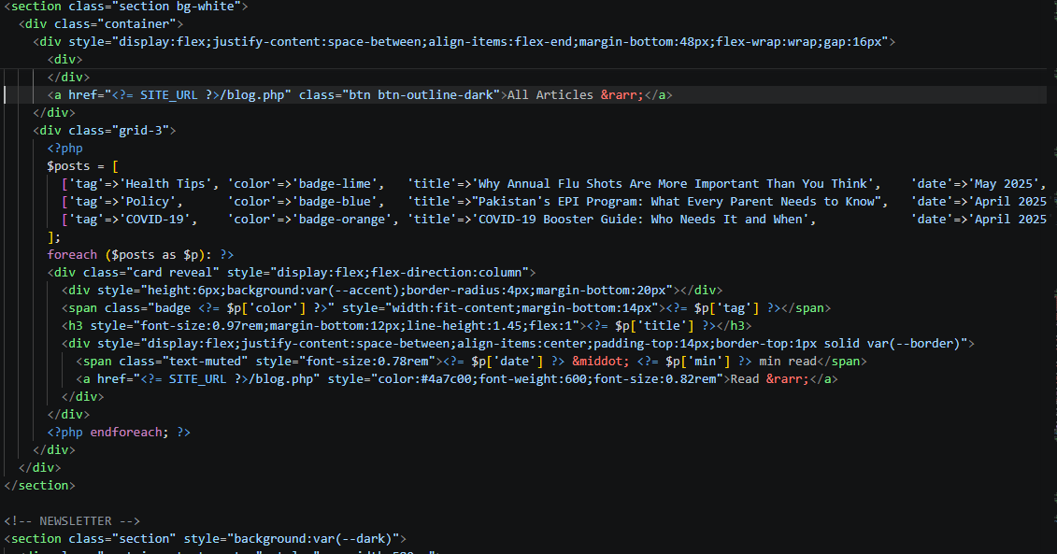

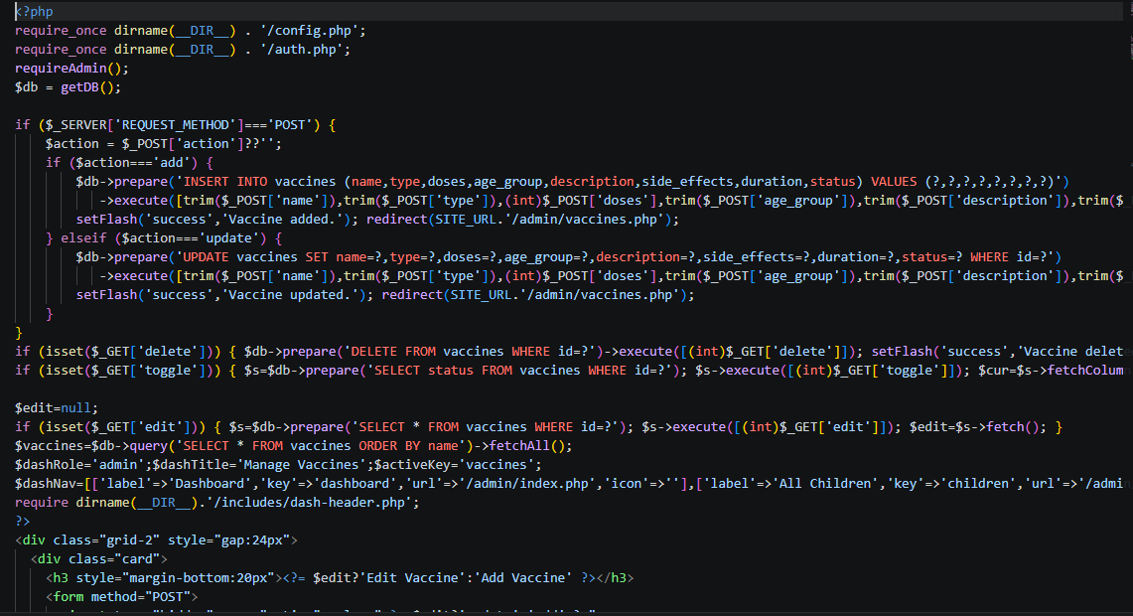

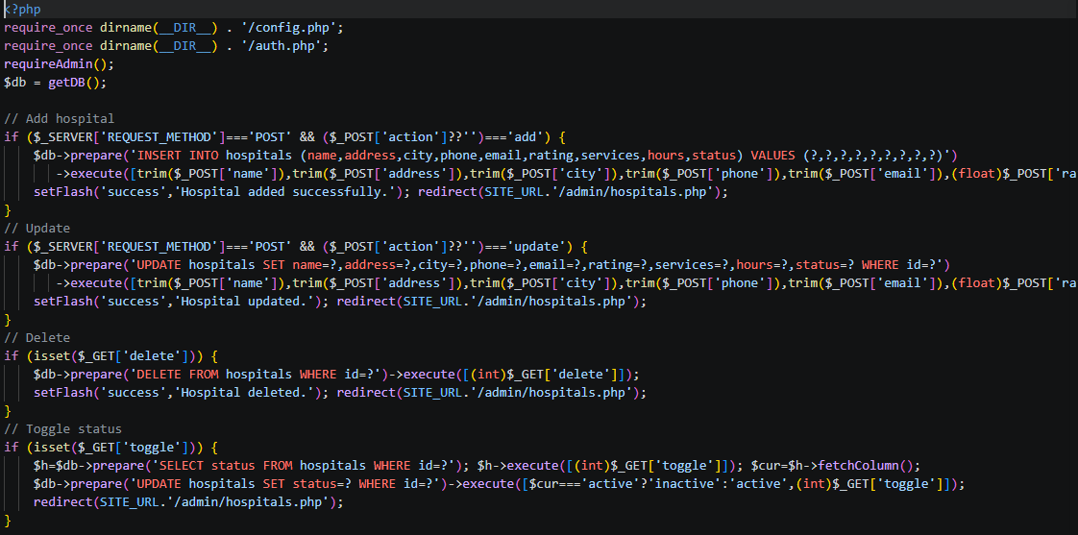

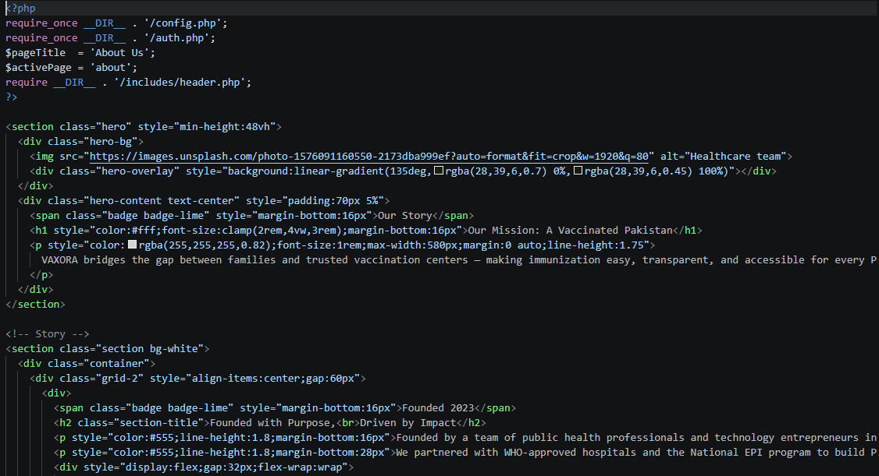

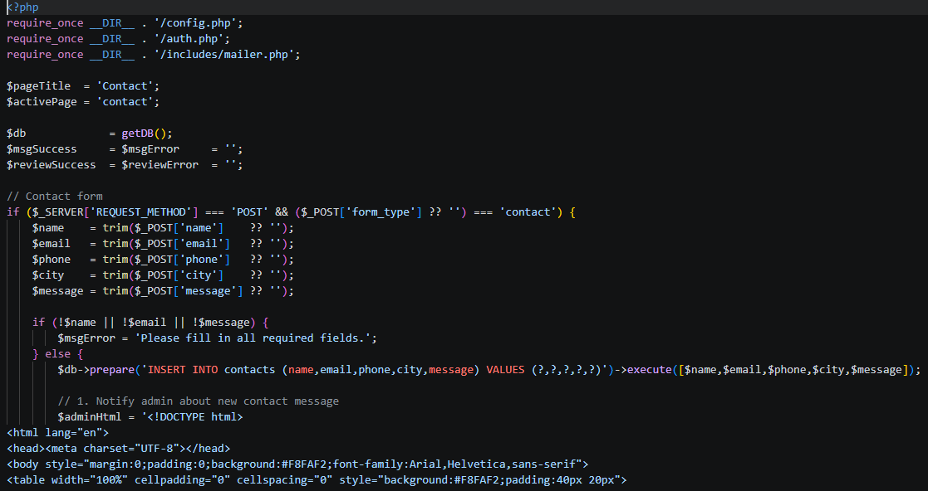

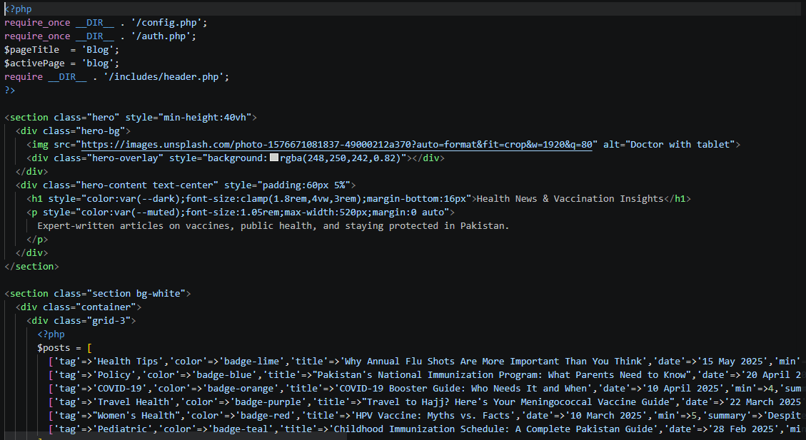

4.14 Dashboard Layout Module (includes/dash-header.php & dash-footer.php)
Shared layout components for all dashboard pages:
- Renders sidebar navigation based on $dashNav array
- Highlights active page using $activeKey
- Displays user name and role in sidebar
- Provides logout link
- Shows flash messages
- Responsive sidebar with mobile toggle
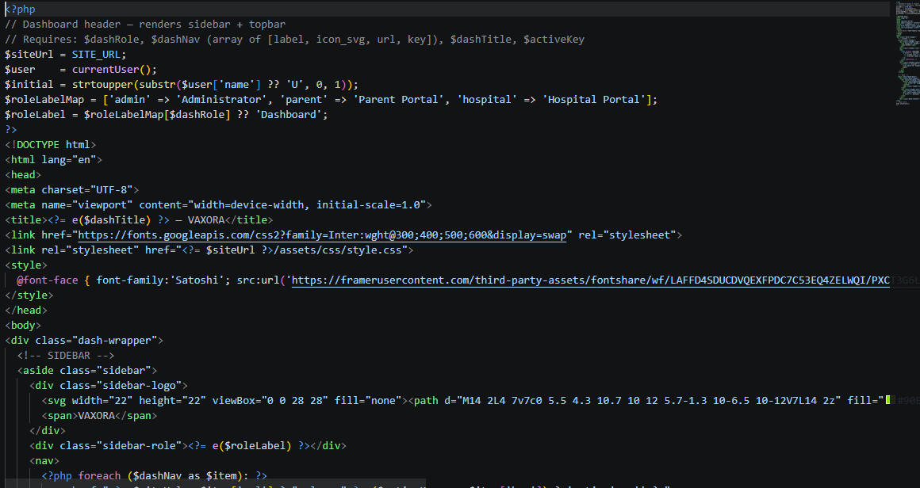

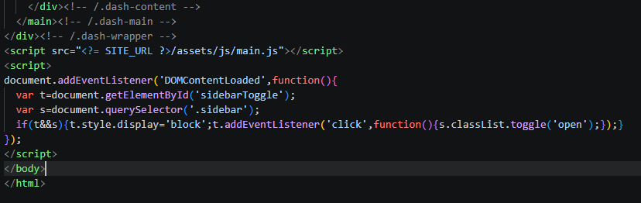

5. Security Implementation

5.1 Authentication Security
- Passwords hashed with bcrypt via password_hash(PASSWORD_DEFAULT)
- password_verify() for login validation (timing-safe comparison)
- Session-based authentication (no tokens exposed to client)
- Role-based access control on every protected page

5.2 Input Validation & Sanitization
- All user inputs trimmed with trim()
- HTML output escaped with htmlspecialchars() via e() helper
- PDO prepared statements with parameter binding for all SQL queries
- Numeric inputs cast to (int) or (float) before database use

5.3 SQL Injection Prevention
- 100% prepared statements – no raw user input in SQL strings
- PDO::ATTR_EMULATE_PREPARES set to false for true prepared statements
- Parameterized queries for all SELECT, INSERT, UPDATE, DELETE operations

5.4 XSS Prevention
- e() function (htmlspecialchars with ENT_QUOTES, UTF-8) used on all dynamic output
- No raw user content rendered without escaping

5.5 Access Control
- requireAdmin(), requireParent(), requireHospital() guard functions
- Child operations verify parent_id ownership
- Hospital operations verify user_id ownership
- Admin has separate login endpoint (/admin/login.php)

6. Installation & Setup

6.1 Prerequisites
- XAMPP/WAMP/LAMP installed with PHP 7.4+ and MySQL 5.7+
- Composer installed (for PHPMailer dependency)
- Web browser for testing

6.2 Installation Steps
Step 1: Copy the vaxora-php folder to your web server’s document root (e.g., htdocs/ for XAMPP).
Step 2: Start Apache and MySQL services.
Step 3: Open phpMyAdmin (http://localhost/phpmyadmin).
Step 4: Create a new database named 'vaxora_db'.
Step 5: Import the vaxora.sql file into the vaxora_db database.
Step 6: Open config.php and verify database credentials:
DB_HOST = 'localhost'
DB_USER = 'root'
DB_PASS = '' (blank for XAMPP default)
DB_NAME = 'vaxora_db'
Step 7: Run 'composer install' in the project root to install PHPMailer.
Step 8: Access the application at http://localhost/vaxora-php/

6.3 Default Login Credentials
Role | Email | Password
Admin | admin@vaxora.pk | password
Parent | ayesha@example.com | password
Hospital | agakhan@hospital.pk | password

6.4 Email Configuration
To enable email notifications, edit includes/mailer.php:
- Set MAIL_ENABLED to true
- Configure SMTP_HOST (e.g., smtp.gmail.com)
- Set SMTP_PORT (587 for TLS, 465 for SSL)
- Enter SMTP_USER and SMTP_PASS
- Set FROM_EMAIL and FROM_NAME

7. Data Flow & Process Diagrams

7.1 Appointment Booking Flow
The vaccination appointment follows this workflow:

Parent registers → Adds child → Selects vaccine + hospital → Submits request
↓
Admin receives pending request
↓
Admin approves/rejects (email sent to parent)
↓
If approved: vaccination_records placeholder created
↓
Hospital sees appointment → Vaccinates child → Updates status
↓
Record marked as completed with dose details

[Screenshot: Process flow diagram for appointment booking]

7.2 User Authentication Flow
User enters credentials → login.php validates
↓
Query users table (email + role + status='active')
↓
password_verify() checks bcrypt hash
↓
Success: Create session → Redirect to dashboard
Failure: Show error message

[Screenshot: Authentication flow diagram]

7.3 Data Flow Diagram (DFD) - Level 0
Context diagram showing external entities and system boundary:
- External Entities: Parent, Hospital Staff, Administrator
- System: VAXORA Vaccination Management System
- Data Flows: Registration data, Appointment requests, Vaccination records, Reports
[Screenshot: Level 0 DFD showing VAXORA context diagram]

7.4 Data Flow Diagram (DFD) - Level 1
Decomposed processes within the system:
- Process 1: User Authentication (login/register)
- Process 2: Child Management (CRUD)
- Process 3: Appointment Booking (request/approve/reject)
- Process 4: Vaccination Recording (hospital updates)
- Process 5: Report Generation (records display)
- Process 6: Hospital Management (admin CRUD)
- Process 7: Vaccine Management (admin CRUD)
[Screenshot: Level 1 DFD showing internal processes]

8. Key Code Patterns

8.1 Database Query Pattern
All database operations use PDO prepared statements:
// SELECT with parameter binding
$stmt = $db->prepare('SELECT * FROM users WHERE email = ? AND role = ?');
$stmt->execute([$email, $role]);
$user = $stmt->fetch();

// INSERT
$db->prepare('INSERT INTO children (...) VALUES (?,?,?,?)')
->execute([$parentId, $name, $dob, $gender]);

// UPDATE
$db->prepare('UPDATE appointments SET status=? WHERE id=?')
->execute([$status, $id]);

8.2 Authentication Guard Pattern
Every protected page starts with:
require_once dirname(__DIR__) . '/config.php';
require_once dirname(__DIR__) . '/auth.php';
requireParent(); // or requireAdmin(), requireHospital()

8.3 Flash Message Pattern
For user feedback across redirects:
setFlash('success', 'Operation completed.');
redirect(SITE_URL . '/parent/children.php');

Displayed in views with:
<?php echo showFlash(); ?>

8.4 CRUD Page Pattern
Most admin/parent pages follow this pattern:
1. Handle POST (add/update) at top of file
2. Handle GET actions (delete/toggle) with redirect
3. Load edit data if ?edit=id present
4. Query list data
5. Set dashboard variables ($dashRole, $dashTitle, $activeKey, $dashNav)
6. Include dash-header.php
7. Render form + list/table
8. Include dash-footer.php

9. Testing & Maintenance

9.1 Testing the Application
- Verify all login credentials work (admin, parent, hospital)
- Test complete appointment flow: register → add child → book → approve → vaccinate
- Verify role-based access (parent cannot access /admin/ pages)
- Test form validations (empty fields, past dates, duplicate emails)
- Check responsive design on mobile and desktop browsers

9.2 Common Maintenance Tasks
- Database backup: Export vaxora_db from phpMyAdmin regularly
- Update PHPMailer: Run 'composer update' for security patches
- Add new vaccines: Use admin panel or insert into vaccines table
- Activate hospitals: Toggle status in admin/hospitals.php
- Clear old data: Archive completed appointments periodically

9.3 Extending the System
To add a new module:
- Create PHP file in appropriate directory (admin/, parent/, hospital/)
- Include config.php and auth.php with appropriate guard
- Set $dashNav, $dashRole, $dashTitle, $activeKey variables
- Include dash-header.php and dash-footer.php for consistent layout
- Add navigation entry to other pages in the same role section
- Create database table if needed (add to vaxora.sql)

